To appear in "Rich Languages from Poor Inputs", Edited by Massimo Piattelli-Palmarini and Robert C. Berwick, Oxford University Press (in preparation for 2012)

**Every child an isolate: nature’s experiments in language learning**

**Lila Gleitman,** Institute for Research in Cognitive Science, UPa

**Barbara Landau,** Dept of Cognitive Science, JHU

*The human language faculty is clearly adequate to the task of constructing a rich linguistic system even under the unusual conditions of an impoverished stimulus delivered through an unlikely channel.*

(C. Chomsky, 1986)

*A complete knowledge of the word includes both…semantic knowledge and all the syntactic knowledge relating to the word.*

(C. Chomsky, 1969)

Carol Chomsky’s (henceforth, CC) studies of language acquisition are as fresh and as central to understanding language acquisition today as they were at their inception four decades ago. Here, we take a retrospective look at how some of her ideas, experimental studies, and perspectives have played out in the literature during the intervening years. As the quotes above hint, we will concentrate our attention on two specific issues that are implicit in CC’s challenge: to understand how children come to know as much as they do about language and its interpretation onto the world, when the information they receive is paltry. The first concerns the robustness of language acquisition to variability in learners’ access to input that would seem crucial to the function being acquired, as dramatized by CC in her studies of language in people who became both deaf and blind during infancy. The second concerns the abilities of children to reconstruct the meanings of sentences with covert structure, as in CC’s landmark studies of whether blindfolded dolls might be hard to see. These two themes are crucially related, of course, for both exemplify the general problem known as “the poverty of the stimulus,” in the present case, how humans reconstruct linguistic form and meaning from the blatantly inadequate information offered in their usable environment (cf Plato, 380bc; N. Chomsky, 1965, J. Fodor, 1981, *inter alia*).

**1.0 ‘See’ and the blind learner**

Children ordinarily acquire their native tongue in circumstances where they can listen to speech that refers to the passing scene. To use a famous example, a lucky learner might hear “Lo! Rabbit!” just as a rabbit hops by. Not only Quine (1960) but serious commentators of every theoretical persuasion are at pains to emphasize that simply alluding to this word-world pairing leaves us light years from the specifics of vocabulary acquisition; indeed exposing the class of problems here is the very purpose of discussing rabbits spied by vexed field linguists (in related regards, see particularly N. Chomsky, 1957; N. Goodman, 1951). All the same, it is safe to say that the sensible pairing of sound to circumstance is a crucial precondition for learning, playing a causal role for both vocabulary and syntax acquisition, and most especially at early stages of those learning processes. After all, children must have access to information allowing them to build representations of the words and sentences they hear, and to interpret them semantically; somehow preliminary information for doing so must be derived from situational contingencies. For this reason, it has been recognized at least since the time of the British empiricists that experience-deprived individuals can provide critical evidence for understanding the learning procedure. For instance, could one acquire the word *red* or even the concept that it linguistically encodes if one could not see? David Hume (1739/1978) voted no:

…wherever by any accident the faculties which give rise to any impression are obstructed in their operations, as when one is born blind or deaf, not only the impressions are lost, but also their correspondent ideas; so that there never appear in the mind the least trace of either of them. ( p. 49).

1.**1 Children who are blind and deaf from early in life**

Helen Keller, blinded and deafened by a sudden high fever in the middle of the second year of her life, learned to speak and understand English – and for good measure learned Latin and Greek and algebra and most of the social graces. She lectured all over the world, interacted easily with Presidents and literary celebrities, and wrote 12 books. Carol Chomsky (1986) studied three children in very similar circumstances, deafened and blinded through illness (usually meningitis and its associated fever) very early in life. “The unusual channel” (as Carol called it) through which language is learned and used by these individuals shows how much can change in the learner’s environment with little consequence for final attainment. To perceive speech at all, the deaf-blind must place their fingers strategically at the mouth and throat of the speaker, picking up the dynamic movements of the mouth and jaw, the timing and intensity of vocal cord vibration, and release of air; the overall method is called Tadoma). From this information, differing radically in kind and quality from the continuously varying speech wave, the deaf-blind recover the same ornate system of structured facts as do hearing learners: for instance, that English has fundamental units including *t, p,* and *a*; that these combine into *tap, apt*, and *pat*, but not (in principle) *tpa*, and that these larger units are categorized into classes distributed differently in the sequences that make up sentences.

But how are these units, so acquired, to stick to the world that they are meant to describe? It seems almost impossible to imagine how these children make contact with the objects, activities, qualities, and relations, being spoken about by their interlocutors but which they can neither see nor hear. Yet enthusiastically describing a recent field-trip, one of these persons, deaf-blind from 19 months of age, remarks:

“I saw one car flattened down to about one foot *high … And my mechanic friend told me that the driver who got out of that cab that was squashed down by accident got out by a [narrow] escape.”* (in C. Chomsky, 1986, p. 337).

So here is language, acquired on a puff of air in a world that ends at the finger tips, complete with embedded relative clauses and including the semantically appropriate use of the word *see.* How can this sophisticated knowledge be explained when the information supplied by the environment is so different and apparently diminished from the usual case?

1,2 **Studies of the blind child**

The present authors made an intensive study of language learning in individuals who were blind from birth (Landau & Gleitman, 1985). This immediate and complete deprivation of visual information can fill some gaps left by the findings for CC’s deaf-blind subjects, two of whom were blinded and deafened at 19-20 months and one at 7 years of age. Arguably these individuals might have made their conceptual and linguistic breakthroughs in the period preceding the illness that robbed them of vision and hearing. Moreover, the tests of their competence were conducted when they were in their 50’s, so that the learning course for them and for sighted individuals might be quite different. Finally, one might argue with the interpretation of the facts. It is noteworthy that clinicians who work with the blind, observing that children in these circumstances utter “look” and “see” freely, are unfazed in their belief that language and concept acquisition arise from the evidence of the senses, counseling parents not to let the children say these words because they must be “empty verbalisms – sound without meaning”.

As we (re)discovered, congenitally blind infants acquire predicates that--to the sighted--refer to visual experience without having had any experience of seeing at all, and they acquire such items at the ordinary times – ages 2 and 3. Many of their earliest words refer to objects, people, places, motions, and locations in ways that seem quite ordinary, even though their experience of such things was surely different from that of the sighted child. Even more surprisingly, and consistent with CC’s findings, among the earliest words in the blind child’s vocabulary were the verbs *look* and *see*, followed shortly by a variety of color terms such as *red, blue*, and *orange*. Sighted blindfolded 3-year-olds told to “Look up!” turn their faces, i.e., their covered eyes, upward, suggesting that they interpret “look” to implicate vision in particular. But a blind 3-year-old given the same command raises her hands rather than her face, suggesting that for her the term is connected to the manual sense (see Figure 2).

Figure 1

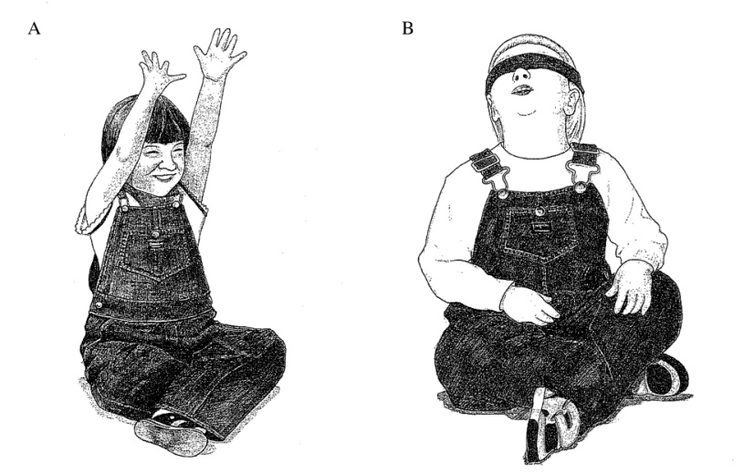

Figure 1. The blind child Kelli responds to the command "look up" by raising her hands (Panel A), while the sighted/ blindfolded child responds by raising her (unseeing) eyes (Panel B). This shows that the blind and sighted child share a representation for "look" that means "perceive", but that the particular modality of perception differs. (Adapted from Landau & Gleitman, 1985).

So far so good for a theory of language learning rooted in experience of the world. The difference in observational opportunities – haptic rather than visual information -- leads the blind and sighted to different interpretations of the same terms. Successful communication from mother to blind child using these visual words often occurred just when the objects to be “looked at” were in the learner’s hands, further suggesting a physical contact interpretation of blind looking. However, this interpretation turns out to be grossly inadequate to the facts of the blind child’s semantic competence. First, several common verbs used by the mother to the blind child shared the property of being uttered— proportionally much more frequently than *look*—when the child had a relevant object in hand, including *hold, give, put* and *play,* all of which are differentiated and used appropriately by blind toddlers. Thus “used with an object in hand” is insufficient to account for why *look* and *see* are the items selected for this semantic purpose. Moreover, the blind interpretation of *look* goes far beyond manual contact. If one says “You can touch that table but don’t look at it!” the blind toddler gingerly taps or scratches at the table. Subsequently told “Now you can look at it,” she systematically explores the surfaces of the table manually. “You can look at this table but don’t touch it” elicits only confused complaints, as it should, i.e., blind looking entails touching whereas neither blind nor sighted touching (necessarily) entails looking. Somehow the blind child extracts from the contextualized speech in her environment that *look* and *see* are terms for perceptual exploration and achievement, quite different in meaning from terms such as *hold* and *touch*.

The blind child’s understanding of color terms offers a similar insight: by about 3 years of age she, like sighted peers, knew that *color* is the supernym of *red* and *green* but not of *happy* or *round*, though of course she had only hearsay knowledge of the actual colors of common things. For instance, asked at age 5 “Can a dog be blue?” a blind child responded “A dog is not even blue. It’s gold or brown or something else.” But more interestingly, when asked “Can an idea be green?” she responded – as did sighted peers -- “Really isn’t green; really just talked about – no color but we think about it in our mind.” Blind learners’ experience with blue dogs and green ideas is exactly the same, namely none. But the response to whether either of these two “could be” some color is different in a principled way.

Summarizing, blind looking differs from sighted looking by being linked to a different spatial sense modality: haptic rather than visual. But blind *look* and *see* differ from *hold, touch*, etc., in being terms of perception. The blind child's understanding of *color* is that it refers to an (unknown) quality of concrete objects and not to mental objects. These findings display the remarkable resilience of semantic acquisition over variations of input: Lacking the ordinarily relevant observations that (one might guess) support solution of the mapping problem for visual terms, the blind are not helpless to do the same.

But then what is the basis for the learning of these terms? Two questions are urgent to engage here: The first is where the information came from. The finding that looking is visual for the sighted but haptic for the blind suggests that for both populations the word meanings are linked to the world, and conform in detail to how the learner infers the semantics from situational contingencies. Maybe this question is in calling distance of an answer if we guess that a sighted child hears *look* when in visual contact (with something) whereas a blind child hears *look* when in haptic contact; that is, adult caregivers are sure to adjust to the facts about the child’s blindness. We will return to this matter later in discussion, trying to unravel a few of the questions we just begged by so saying. But the finding that terms like l*ook* are perceptual, distinct from such contact terms as *touch* and *set eyes on* seems even less straightforward. It is this second question that brings us to the second major line of CC’s investigations of language learning.

2.0 **Why is *easy* hard? The syntactic encoding of argument structure**

**2.1 The experiments**

Carol Chomsky approached the problem of how children learn predicate semantics from the point of view of how they learn syntax (1969). This is the sense of the second quote with which we began this chapter. At a time when few language acquisition researchers studied anything more complex than two word speech and its inchoate surface organization (e.g., Braine ,1963), CC was studying children’s knowledge of delicate aspects of English verbal syntax, using ingenious and carefully controlled elicitation procedures. Famously, she asked if a blindfolded doll is “hard to see.” And her 4 and 5 year-old subjects confidently replied yes, “because of the blindfold.” One revelation from this work is thus that learning isn’t all over and done with by 3 or 4 years of age; rather, complexities are still evolving through the school years, with a certain few structures appearing to elude some native speakers throughout life. Notice that the root meaning of *hard* isn’t what’s making the difficulty, for this much young children understand by age 2 or 3. Rather, they misunderstand the associated requirement that the (covert) subject of the infinitive in the complement clause is not *doll* but an implied party who can be anybody except the doll. In contrast, in “This doll is eager to see” the subject of the infinitive, the one who sees, is indeed the very doll who is eager to do so.

**2.2 Explanations: the minimum distance principle:**

CC studied several other English structures, very different in their syntax and semantics from *easy/eager*, finding the same disparities in learning rate and character depending, again, on how grammatical subjects are assigned to infinitival complement clauses. For instance, a cooperative response to “Tell Bozo *to jump*” is “Jump, Bozo!” a command directed to Bozo. But the appropriate response to “Promise Bozo *to jump*” is something like “Bozo, I promise I’ll jump.” *Tell* treats its object NP as subject of the embedded clause but *promise* assigns this role to the subject NP.

A single principle predicts the facts of interpretation and learning disparity for both *tell/promise* and *easy/eager*. CC expressed this as a “minimum distance” principle (MDP), i.e., the structurally closest NP argument of the upstairs clause is the mandatory subject of the infinitive in the embedded clause. Because this principle holds very generally in English – so said CC – any violations of it, such as in *easy* and *promise* constructions*,* should be, and are, hard for children to learn. Regularities first, exceptions later.

**2.3** S**yntactic principles and semantic interpretation: *hard* and *easy*, together again.**

Perhaps the apogee of this line of reasoning is CC’s explication of the relationship between the syntactic principles she uncovered and the semantic interpretation of predicates for which they are licensed. In her words, “We have two semantic classes and an unambiguous syntactic process associated with each.” Specifically, command verbs (*tell, order*, etc.) obey MDP while *promise* verbs do not. And verbs of requesting, which arguably fall semantically between the two, accept either choice. Hence the ambiguity of “I *asked* the teacher to leave the room” and of “These missionaries are *ready* to eat”. [fn]. Generalized, the idea is that the argument-taking properties of predicates are reflected in the (interpreted) syntactic structures that they license: If *easy* is *hard*, then *hard* simply can’t be *easy*. Thus one learning dictum implied by these studies is that knowledge of the root meaning predicts aspects of clause structure (for extensive discussion, Pinker, 1984; 1989; Grimshaw, 1980; for experimental evidence of the predictive power and stability of these mappings, see Fisher, Gleitman, & Gleitman, 1991; Fisher, Hall, Rakowitz, & Gleitman, 1994). When these expectations are frustrated, sentences containing the predicate are likely to be misinterpreted.

--------------------

[fn] A 7-year old of our acquaintance explained what this sentence could mean “Either I asked the teacher if I could leave the room to go to the bathroom or if she would leave the room so I could go to the bathroom in privacy.”

**2.4 Learning effects of universal correspondence rules**

In her early studies,CC described MDP and its associated semantic linking as a dominant pattern specific to English, explaining the late learning of *easy* structures as arising from their observed irregularity for the input corpus as a whole (Slobin, 2001, has coined the term “typological bootstrapping,” to describe this learning phenomenon). There is of course considerable evidence that a significant proportion of these linkages represent universal tendencies in how languages map between clause structure and the argument-taking properties of predicates (Baker, 2001; N. Chomsky, 1981; Croft, 1990; Dowty, 1991; Fillmore, 1968; Jackendoff, 1983; Rappaport Hovav & Levin, 1988, *inter alia*) and in several known cases, cross-language stability in this regard predicts learning rate just as it did in CC’s early studies of child English.

One further extensively studied instance concerns locative verbs that describe the relation (spatial or at least metaphorically spatial) between some moving entity (the Figure) and its position (Ground); for discussion see Talmy, 1985, and in the learnability context, Pinker, 1989). These vary in their syntax both within and across languages as to whether Figure or Ground term captures the direct object position. Sometimes a single language has a pair with different morphology representing these choices (e.g., *substitute/replace*, *pour/fill*) and sometimes not (e.g., *load*, as in both “John loaded hay into a wagon/loaded a wagon with hay”, C. Fillmore, 1968). Early diary studies from Bowerman (1982) documented errorful learning for some of these items. Kim, Landau & Philips (1999) examined the learning functions for a variety of such items in Korean and English. Of special interest in the present context, they showed that errors and late learning are largely confined to cases in which different languages vary in their patterning for verbs whose root meaning is the same. For instance English three year olds say “Fill water into the glass” almost 100% of the time though this is a Ground verb in English. But it is a Figure verb in Thai, and an Alternator in Korean and Singapore Malay. This again shows that universal correspondence patterns are playing a powerful learning role, for learning is decremented where there is cross-language variability in the mappings. There seem to be more and less natural correspondence patterns.

2.5. **The scope and power of linking rules as information sources for learning**

We have just discussed some instances in which NP positioning (including covert NP’s) is conditioned by semantic factors and plays a role in acquisition. It is well known from extensive linguistic investigation that argument type and number also map systematically onto a semantic cross-classification of the verb lexicon (see earlier citations, also Levin for an English compendium, and Pinker, 1989, Gleitman 1990, and Fisher, Hall, Rakowitz & Gleitman, 1994 for discussions of learning implications). Verbs that accept sentences as their complements describe relations between their subjects and an event or state; these include verbs of cognition (*know, think*), perception (*see*, *hear*), and communication (*explain, say*). Verbs that license three noun-phrase arguments describe relations among the referents of those three noun phrases, typically transfer of position (*put, drop*), possession (*give, take*), or information (*explain, argue*). These regularities can be recovered from a sample of English sentences produced in spontaneous child-directed speech in languages as disparate as English (Lederer, Gleitman, & Gleitman, 1995), Mandarin Chinese (Li, 1994), and Hebrew (Geyer,1991). Thus verbs’ syntactic behavior provides a potential source of information that systematically cross-classifies the set of verbs in much the same way within and across languages, pointing to the same dimensions of semantic similarity; a corpus with these characteristics is readily available in natural speech to infant learners.

Recent experimentation demonstrates that this source of information is heavily exploited by learners in interpreting novel predicates (e.g., Fisher et al, 1994; Gleitman, 1990; Fisher, 1996; Gillette, Gleitman, Gleitman, & Lederer, 1999; Gleitman et al, 2005; Lidz, Gleitman, & Gleitman, 2003; Landau & Stecker, 1990, among many sources). Thus, infants under two years of age interpret “gorp” as encoding a causal predicate in “The rabbit is gorping the dog” but not in “The rabbit and the dog are gorping,” though they are seeing the same scenario play out in both cases (Naigles, 1990). Symmetrically, three- and four-year olds reinterpret known verbs in new ways if they are used in novel constructions “Noah comes the elephant to the ark.” Is interpreted as a verb of transfer (*bring*) while “Noah brings to the ark” is interpreted as a noncausal verb of motion (*come*). (Naigles, Gleitman, & Gleitman, 1993). The same interpretive strategies, corrected for other architectural principles that differentiate languages, have been documented for young learners in languages as disparate as English, Greek, Kannada (e.g., Lidz et al, 2003, Papafragou, Cassidy, & Gleitman, 2007). The children’s inferential method would seem analogous to how we understand Lewis Carroll’s “Jabberwocky” consensually though its content words are apparently so much nonsense. Borogoves, for example, likely are indulging in some self-caused activity when they gyre in the wabe*.* This likelihood arises palpably from the fact that the nonsense verb is surfacing in a one-argument structure We can further examine this argument-number clue to predicate interpretation by reference to another of nature’s experiments: language learning in young deaf children.

**2.6** **The isolated Deaf: linguistic input deprivation:**

Some of the most striking evidence that the structure of human cognition yields a language-appropriate division of our thoughts into semantically constrained predicates and arguments comes from learners who are isolated from ordinary exposure to a language and therefore have to invent one on their own. Most deaf children are born to hearing parents who do not sign, and therefore the children may not come into contact with gestural languages for years (Newport, 1990). Deaf children with no available language model spontaneously invent gesture systems called “Home Sign” (Goldin-Meadow, 2003; see also Senghas, 2003 for evidence of how fully and rapidly such systems evolve if there is a viable interactive community). Remarkably, though these children are isolated from exposure to any conventional language, their home sign systems partition their experience into the same pieces that characterize the elements of sentences in Italian, Inuktitut, and English. Specifically, home sign systems have nouns and verbs, distinguishable from each other by their positions in the children’s gesture sequences and by their distinctive iconic properties. Moreover, and especially pertinent to the issues that we have been discussing, sentence-like combinations of these gestures vary in both the number and positioning of the nouns as a function of what their verbs mean. Systematically appearing with each verb in a child’s home sign system are other signs spelling out the thematic roles required by the logic of the verb: the *agent* of the act, the *patient* or thing affected, and so forth (Feldman, Goldin-Meadow & Gleitman, 1978). The nature of this relationship is easy to see from a few examples: Because crying involves only a single participant (the crier), a verb with this meaning is associated with only one nominal argument. Because tapping has two participants, the tapper and the thing tapped, such verbs may appear with two nominal arguments. Because giving requires a giver, a getter, and a gift, this verb is associated with three nominal phrases in the deaf children’s spontaneous signing (cf. N. Chomsky, 1981). Thus the same fundamental relationships between verb meaning and nominal arguments surface in much the same way, and at the same developmental times, in the speech of children who are acquiring a conventional language, and in the gestures of linguistically isolated children who must invent one for themselves. Such findings tend to undermine some theories of acquisition positing that verb structures are learned one by one “from the input” (e.g., Tomasello 2002). As deaf isolates factor experience into predicates and arguments of varying types without any input at all, it seems unlikely that there is a stage at which more fortunately circumstanced children have to learn the same facts in a one-by-one stipulative fashion. [fn]

____________________________________________________________

[fn] As in the speech of all young learners, the actual sequences produced by two- and three-year old deaf isolates are usually very short, with a surface length of only two or a few words, but the covert structure of complex predications can be reconstructed by examining patterns in which some argument types are dropped (“deleted”) selectively. (L. Bloom, 1968)

_____________________________________________________________

In sum, linguistically isolated children construct, out of their own thoughts and communicative needs, systems that resemble the languages of the world in at least the following universal regards: All have words of more than one kind, at minimum nouns and verbs, organized into sentences expressing predicate-argument relations. The number of noun phrases is predictable from the meaning of the verb; the positioning of the nouns expresses their semantic roles relative to the verb. Thus, the fundamental structure of the clause in both self-generated and more established communication systems derives from the nonlinguistic conceptual structures by which humans represent events, with strong preferences about how to sequence these in linguistic expressions.

2.7. ***See* must mean ‘perceive haptically.’**

We can now revisit the specific question with which we began: How blind and blind-deaf learners come to believe that *look* and *see* are haptic perceptual terms, and that touch is merely a contact term. The answer comes apart into the two aspects of “knowledge of the word” that CC describes in the opening quote. The root meaning of *look/see* as inferred from the situations in which it is said, requires haptic contact. Adults speaking to the blind do not tend to say “Look at the moon” or “Do you see that bird flying overhead?” whereas these are likely conversational topics when addressing sighted children who have the visual distance receptor. This difference in the environments of discourse predicts a difference in the meaning of these terms, and this is just what is found. There is no internal linguistic marking of perceptual modality that would rein in such a distinction.

In contrast, the argument-taking properties are recoverable by blind and sighted learners alike if, as we have argued, they have antecedent access to universal syntactic-semantic linking rules. Learning can here transcend observational information in the nonlinguistic situation, by analyzing the heard sentence itself. As we have already mentioned, mental content verbs including verbs of perception, belief, and desire, license clausal complements where other verbs do not (for experimental documentation with young children, Papafragou et al., 2007.) One can intelligibly and grammatically say “Look who’s coming to dinner” and “Let’s see if there’s cheese in the refrigerator” but these structures are proscribed for action verbs such as *jump* or *touch*. Landau and Gleitman exhaustively coded transcripts of maternal speech to a blind child in the earliest period of word learning (before the learner uttered any verbs), finding that the structural contexts for the perception verbs (their subcategorization frames) selected *look* and *see* as the only items that appeared with embedded tensed clausal complements,, e.g., “Let’s see if there’s cheese in the refrigerator.” (See Figure 2, and for further documentation, Snedeker & Gleitman, 2004).

Figure 2

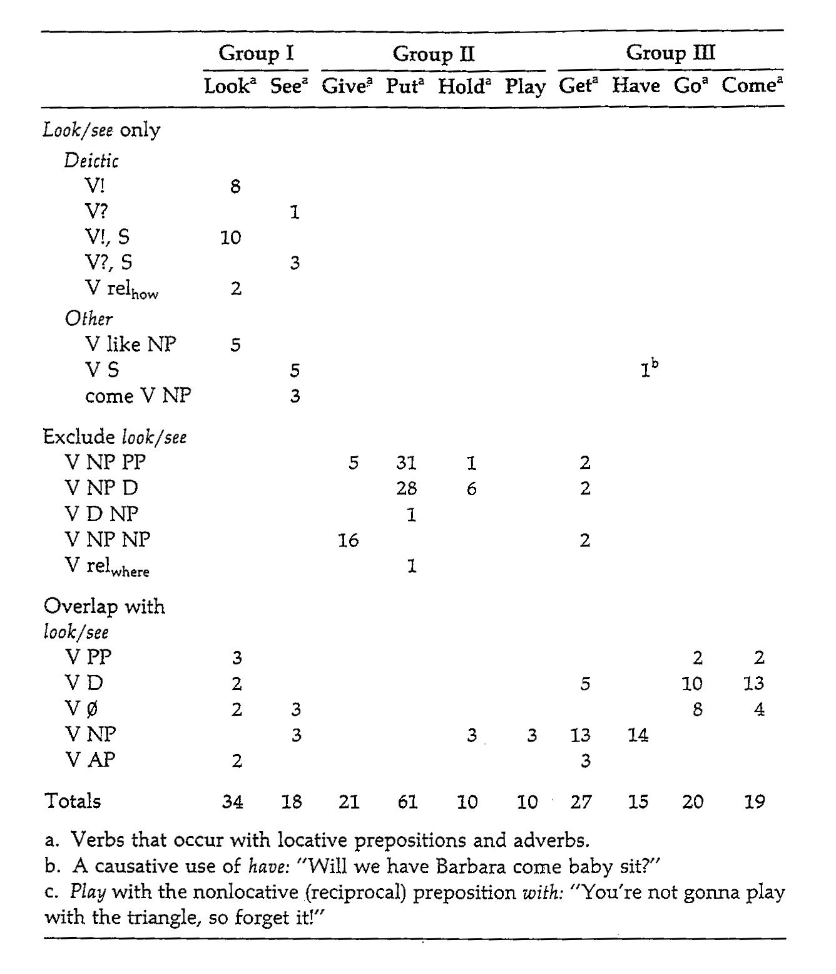

Figure 2. Subcategorization frames used by the mother of the blind child for verbs *look* and *see* compared to other verbs. Note that only *look/ see* occur with sentential complements, whereas verbs involved in transfer (*give, put)* or other activities involving the haptic modality ( *hold, play*) participate in a different range of frames not used with *look/ see*. More generally, the three sets of verbs participate in different sets of syntactic frames, suggesting that the verb classes can be distinguished by the syntactic frames in which they occur, and could serve as a crucial source of information for the learner (blind or sighted) about the verb's meaning. (Adapted from Landau & Gleitman, 1985).

Before leaving this topic, we should say that in at least some central cases the kinds of syntax-semantics correspondences that are found in language after language are not simply stipulative; rather, the forms transparently embody their semantics. For example, what could be more natural than that each argument of a predicate should surface as a noun-phrase, and that therefore *pat* will be treated transitively and *snore* intransitively? As for *see*, it expectedly appears with NP objects just because one can perceive *things* (and things generally surface as nouns, as any school teacher would tell you). But *see* also expectedly appears with sentential complements because one *can perceive events and states of affairs* (and whole events surface as clauses). Just as expectedly the contact term *touch* behaves like *see* in the first regard (it is transitive) but not the second (no clausal complements).

3.0 **Every child an isolate**

This chapter has reviewed some of Carol Chomsky’s early experimental studies of language acquisition, emphasizing its continuing relevance to the theory of language acquisition. The deep subtext of this work concerns the poverty of the stimulus problem. Successful language learning takes place under conditions of input deprivation that intuition suggests would pose insuperable problems. These include deaf-blind people acquiring linguistic-conceptual categories whose instances they cannot experience. Thus usable input can differs radically across populations of learners, but the outcome is the same, contra Hume. The other symmetrically related finding is that all of the learners acquire delicacies of syntactic form and interpretation that (if we are literal) are experienced by nobody. Thus certain arguments of embedded infinitivals are never “there” in the utterance, they are as a matter of syntactic necessity empty of phonetic content. Yet as CC documented, these arguments are reconstructed, and reconstructed *differently,* depending on their predicate context – systematically different cases of “nothing.” But as CC also showed, knowledge of these syntactic properties of lexical items often, and crucially, occurs with very significant delay: Children know the semantic difference between *easy* and *hard* at age two or so, but they misinterpret sentences containing these words well into the school years.

3.1. **Real world context: Crucial but limited**

Part of the explanation for why defects in situational context are readily overcome and in part discounted in vocabulary learning is that their role is more limited than one might think. A three-year-old’s vocabulary contains an impressive proportion of items for which the observed world yields little or no straightforward interpretive clues: You can’t see *thinking*, or *maybe*, or *seem*, or *wanting*, or *fair* (as in “not fair!”) It is hard to observe forests and pets, physical as these are, because one observes the trees and dogs instead. Even apparent “action” predicates have subtle mental content that can’t be observed. For instance, notice that while it may be a bit hard to *get* blood from a stone, it is impossible to *give* it any: *Give* requires a sentient recipient. Yet very young preschoolers acquire such items and use them appropriately, so far as can be determined. Finally, careful inspection of the real contexts in which even concrete object nouns are acquired must leave one puzzled about how this could help very much. For example, a picture-book context like that of Figure 3a might be envisaged as helpful indeed for learning the meaning of “shoe,” and maybe it is. But the fact is that the context of Figure 3b is more like what children experience every day, and “from” which they learn most of their early vocabulary. One line of investigation finds that fewer than 8% of the situational contexts of natural parental talk to infants offers observers – child or adult – a fighting chance (50% correct) to guess a simple whole-object term – a concrete noun -- that the mother was then uttering; this is studied by videotaping minute-long scenes of actual parent-infant conversation with the sound muted (Medina, Snedeker, Trueswell, & Gleitman, submitted; Snedeker= and Gleitman 2004). Inefficient and errorful as this guessing game is for concrete nouns, it is materially worse for learning other linguistic categories – the verbs, adjectives, and so forth. Moreover, cross-situational observation, i.e., further situational input, complicates this picture rather than resolving it because, in the ever-changing situations in which some single word is uttered, plausible hypotheses proliferate almost limitlessly and overtax memorial resources.

Figure 3a

C:\Documents and Settings\Lila\Local Settings\Temporary Internet Files\Content.IE5\GTSSZD7G\MC900083091[1].wmf

Figure 3b

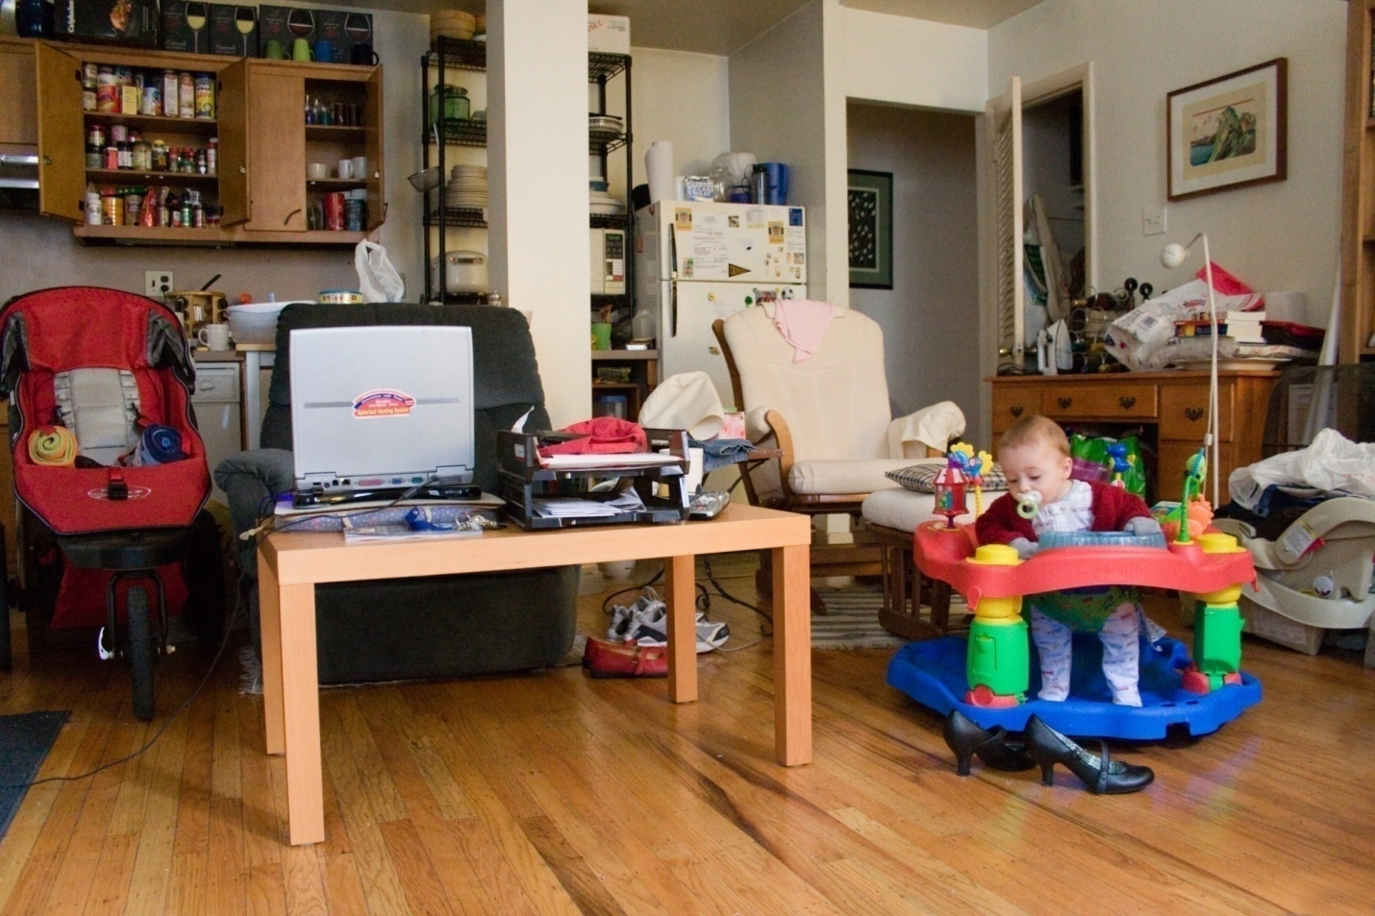

Figure 3. What is the situational context for learning the meaning 'shoe'?   Panel A:  an idealized environment; Panel B: a snapshot of a child's everyday environment.

3.2. **Single observations, multiple cues**

We just noted that even adults are quite inept at guessing the meaning of simple words from their situational contingencies, and are successful at all only for concrete object nouns. Similarly, word learning in infants until about 18 months slow and largely restricted to concrete nouns (Gentner & Boroditsky, 2001; Fenson et al, 1994).However, toward the end of the first year of life the rate of word learning accelerates materially, to about 8 words a day, and continues at this rate for all the many months and years thereafter; as this implies, learning now seems to require only one or very few exposures, and is essentially errorless (Carey, 1978; P. Bloom, 2002). What has changed at this later stage?

The approach that seems most promising today takes into account the fact that multiple cues to a word meaning are present simultaneously when a word is heard. These include not only a sound and its contingent situation, but also the structure in which the word occurs. As already noted, this syntactic information, once acquired, has the potential for picking out certain semantic classes (e.g., the command verbs, the request verbs; the mental verbs; the perception verbs).

Thus we can envisage a learning procedure that begins by pairing words to their observational contingencies. Such a procedure will be slow and errorful, accruing primarily concrete (“observable”) words. Limited as this early vocabulary is, it provides first ways to refer to the world, and a scaffold for projecting the language-specifics of clause level syntactic structure, e.g., that English is SVO (Pinker, 1984; Grimshaw, 1981). These clause structures are further differentiated syntactically (and sometimes morphologically), in accord with their interpretations. In the mature machinery emerging from the age of two years through the early school years, and as CC suggested, “all this syntactic knowledge relating to the word” then becomes a further source of interpretive inference because it is keyed semantically to the argument-taking properties of the component predicates. Situational and syntactic cues can now trade and conspire with each other to overdetermine the meanings of words that observation, operating alone, cannot reveal. Easy.

**References**

Baker, M. C. (2001). *The atoms of language: The mind's hidden rules of grammar.* New York, NY: Basic books.

Bloom, L. (1970). *Language development: Form and function in emerging grammars*.  Cambridge MA: The M.I.T. Press.

Bowerman, M. (1982). Reorganizational processes in lexical and syntactic development. In E. Wanner, & L.R. Gleitman (Eds.), *Language acquisition: State* *of the art* (pp. 319-346). Cambridge MA: Cambridge University Press.

Braine, Martin D. S. (1963). The Ontogeny of English Phrase Structure: the First Phase. *Language,* *39*, 1-13.

Carey, S. (1978). The child as word learner. In M. Halle, J Bresnan & G.A. Miller (Eds.), *Linguistic theory and psychological reality* (pp. 264-293). Cambridge MA: MIT Press.

Chomsky, C. (1986). Analytic study of the tadoma method: Language abilities of three deaf-blind subjects. *Journal of Speech and Hearing Research, 29*(3), 332.

Chomsky, C. (1969), The Acquisition of Syntax in Children from Five to Ten. In *Research Monograph No. 57*, Cambridge, MA: MIT Press.

Chomsky, N. (1981). *Lectures on government and binding*. Dordrecht: Foris.

Chomsky, N. (1965). *Aspects of the theory of syntax*. Cambridge, MA: MIT Press.

Chomsky, N. (1957). *Syntactic structures*. London: Mouton and Company.

Croft, W. (1990). *Typology and universals*. New York: Cambridge University Press.

Dowty, D. (1991). Thematic proto-roles and argument selection. *Language, 67*, 547-619.

Feldman, H., Goldin-Meadow, S., & Gleitman, L. R. (1978). Beyond Herodotus: The creation of language by linguistically deprived deaf children. In A. Lock (Ed.), *Action, symbol, and gesture: The emergence of language* (pp. 351-414). New York: Academic Press.

Fenson, L., Dale, P. S., Reznick, J. S., Bates, E., Thal, D. J., Pethick, S. J., Tomasello, M., Mervis, C. B., Stiles, J. (1994). Variability in early communicative development. *Monographs of the Society for Research in Child Development, 59*(5).

Fillmore, C. J. (1968). The case for case. In E. Bach & R. T. Harms (Eds.). *Universals in linguistic theory* (pp. 1-88). New York: Holt, Rinehart and Winston, Inc.

Fisher, C. (1996) Structural limits in verb mapping: the role of analogy in children’s interpretation of sentences. *Cognitive Psychology, 31*, 41-81.

Fisher, C., Gleitman, H., & Gleitman, L. R. (1991). On the semantic content of subcategorization frames. *Cognitive Psychology, 23*, 331-392.

Fisher, C., Hall, D. G., Rakowitz, S., & Gleitman, L. (1994). When it is better to receive than to give: Syntactic and conceptual constraints on vocabulary growth. *Lingua, 92*, 333-375.

Fodor,, J. A. (1981). The Present Status of the Innateness Controversy. In J. A. Fodor (Ed.), *Representations*. Cambridge, MA: MIT Press.

Gentner, D., & Boroditsky, L. (2001). Individuation, relativity and early word learning. In M. Bowerman & S. C. Levinson (Eds.), *Language acquisition and conceptual development* (pp. 215-256). New York: Cambridge University Press.

Geyer, H. (1991). *Sub-categorization as a predictor of verb meaning: evidence from modern Hebrew.* Unpublished manuscript, University of Pennsylvania.

Gillette, J., Gleitman, H., Gleitman, L. R., & Lederer, A. (1999). Human simulations of vocabulary learning. *Cognition, 73*, 135-176.

Gleitman, L. R. (1990). The structural sources of verb meanings. *Language Acquisition, 1*, 3-55.

Gleitman, L.R., Cassidy, K., Papafragou, A., Nappa, R., & Trueswell, J.T. (2005) Hard words, *Journal of Language Learning and Development,* *1*(1), 23-64.

Goldin-Meadow, S. (2003). The resilience of language: What gesture creation in deaf children can tell us about how all children learn language. In J. Werker & H. Wellman (Eds.). *The Essays in Developmental Psychology Series*. New York: Psychology Press.

Goodman, N. 1951. *The Structure of Appearance.* Cambridge, MA: Harvard University Press.

Grimshaw, J. (1981). Form, function, and the language acquisition device. In C. L. Baker & J. J. McCarthy (Ed.), *The logical problem of language acquisition* (pp. 165-182). Cambridge, MA: MIT Press.

Hume, D. (1739/1978). *A treatise on human nature*. Oxford: Clarendon.

Jackendoff, R. (1983). *Semantics and cognition*. Cambridge MA: MIT Press.

Kim, M., Landau, B., & Phillips, C. (1999). Cross-linguistic differences in children's syntax for locative verbs. *Proceedings of the 23rd Boston University Conference on Language Development,* 337-348.

Landau, B., & Gleitman, L. R. (1985). *Language and experience: Evidence from the blind child.* Cambridge, MA: Harvard University Press.

Landau, B., & Stecker, D. (1990). Objects and places: Geometric and syntactic representations in early lexical learning. *Cognitive Development, 5*, 287-312.

Lederer, A., Gleitman, H., & Gleitman, L. (1995). Verbs of a feather flock together: Semantic information in the structure of maternal speech. In M. Tomasello & W. E. Merriman (Ed.), *Beyond names for things: Young children's acquisition of verbs* (pp. 277-297). Hillsdale, NJ: Lawrence Erlbaum Associates.

Levin, B. (1993). *English Verb Classes and Alternations: A Preliminary Investigation.* Chicago, IL: University of Chicago Press.

Li, P. (1994). *Subcategorization as a predictor of verb meaning: Cross-language study in Mandarin*. Unpublished manuscript, University of Pennsylvania.

Lidz, J., Gleitman, H. and Gleitman, L., 2003. Understanding how input matters: Verb learning and the footprint of universal grammar. *Cognition,* *87*, 151–178.

Medina, T. N., Snedeker, J., Trueswell, J. C.,& Gleitman, L. R. (in preparation). *When does the shoe fit? How words can (and cannot) be learned by observation.*

Naigles, L. G. (1990). Children use syntax to learn verb meanings. *Journal of Child Language, 17*, 357-374.

Naigles, L. G., Gleitman, H., & Gleitman, L. R. (1993). Children acquire word meaning components from syntactic evidence. In E. Dromi (Ed.), *Language and cognition: A developmental perspective* (pp. 104-140). Norwood, NJ: Ablex.

Newport, E. L. (1990). Maturational constraints on language learning. *Cognitive Science, 14*, 11-28.

Papafragou, A., Cassidy, K., Gleitman. L. R. (2007). When we think about thinking: The acquisition of belief verbs. *Cognition,* *105,* 125-165.

Pinker, S. (1989). *Learnability and cognition*. Cambridge, MA: MIT Press.

Pinker, S. (1984). *Language learnability and language development*. Cambridge MA: Harvard University Press.

Plato (c.380bce/ 2010) Meno, in *Dialogues of Plato: Translated into English, with analyses and introduction* by B. Jowett*.* Cambridge: Cambridge University Press.

Rappaport Hovav, M., & Levin, B. (1988). What to do with theta-roles. In W. Wilkins (Ed.), *Syntax and semantics, volume 21: Thematic relations* (pp. 7-36). New York: Academic Press.

Senghas, A. (2003). Intergenerational influence and ontogenetic development in the emergence of spatial grammar in nicaraguan sign language. *Cognitive Development, 18*(4), 511-531.

Slobin, D. I. (2001). Form-function relations: How do children find out what they are? In M. Bowerman & S. C. Levinson (Eds.), *Language acquisition and conceptual development* (pp. 406-449). New York: Cambridge University Press.

Snedeker, J., Geren, J., Shafto, C. (2007). Starting over: International adoption as a natural experiment in language development. *Psychological Science,* *18*(1), 79-87.

Snedeker, J. & Gleitman, L. (2004). Why it is hard to label our concepts. In Hall, G. & Waxman, S. (Eds.), *Weaving a Lexicon*. Cambridge, MA: MIT Press.

Quine, W. (1960). *Word and object*. New York: Wiley.

Talmy, L. (1985). Lexicalization patterns: Semantic structure in lexical forms. In T. Shopen (Ed.), *Language typology and syntactic description* (pp. 57-149). New York: Cambridge University Press.

Tomasello, M. (2000) Do young children have adult syntactic competence? *Cognition*, 74(3), 209-253.